VTPACT Autopilot Configuration
Created and Maintained by Garrett Asper garrettasper@vt.edu

PX4 Repository Setup

Setting up the Windows-Linux (WSL) Toolchain
These procedures are to install WSL - Ubuntu 22.04.3 LTS
These steps were revised and validated over several installations on different devices running Windows 11. These steps come without warranty nor guarantee of success.
In the command prompt as the administrator, run
wsl.exe –install
If this does not successfully install the program, a series of steps to enable virtualization will need to be performed as the administrator in PowerShell
dism.exe /online /enable-feature /featurename:Microsoft-Windows-Subsystem-Linux /all /norestart
dism.exe /online /enable-feature /featurename:VirtualMachinePlatform /all /norestart
Enable-WindowsOptionalFeature -Online -FeatureName VirtualMachinePlatform -NoRestart
Then, restart the computer, and run the same three commands again as the administrator in PowerShell
Note: The fourth command will change the version of WSL to version 2
dism.exe /online /enable-feature /featurename:Microsoft-Windows-Subsystem-Linux /all /norestart
dism.exe /online /enable-feature /featurename:VirtualMachinePlatform /all /norestart
Enable-WindowsOptionalFeature -Online -FeatureName VirtualMachinePlatform -NoRestart
wsl --set-default-version 2
Then, close PowerShell and open the command prompt (not as the administrator) and run
wsl --update
wsl.exe --install Ubuntu
Then, the user will be prompted to enter a username and password for use when performing root operations with WSL.
Then, search for WSL in the windows search bar
In WSL, send the following commands
sudo apt update && apt upgrade
WSL will then prompt the user for the password setup for root operations in the previous step. Now the PX4 repository can be cloned.

Cloning the PX4 Repository
Open the WSL application and send the following commands
(where <px4_repo_name> is the name of the folder your repository will be under)
mkdir <px4_repo_name>
cd <px4_repo_name>
git clone https://github.com/PX4/PX4-Autopilot.git --recursive

This step will take a while to clone the repository. Once it is done and while in the directory of the <px4_repo_name>, enter the following commands
cd PX4-Autopilot
git checkout v1.14.0 -f
git submodule update --init --recursive
cd Tools/setup
bash ./ubuntu.sh
The bash command will require root access (so the password for sudo) if it has not already been entered in this session of using the WSL terminal. After the setup process completes, restart your device.

The next steps will take place in the hardware setup screens in MATLAB.

UAV Toolbox Setup

Installing the Right Programs
The following programs are needed for the UAV Toolbox – PX4 toolchain
- MATLAB
- Simulink
- MATLAB Coder
- Simulink Coder
- Embedded Coder
- UAV Toolbox
- UAV Toolbox Support Package for PX4 Autopilots
  - During Configuration
    - Python (v. 3.3.4) (The UAV Toolbox auto-installs 3.8, but 3.3.4 is the necessary version
- MATLAB Support for the MinGW-w64 C/C++/Fortran Compiler
- QGroundControl (v. 4.2.8)
- MissionPlanner (for CubePilot drivers)
- RFDTools (v2.67)
- DroneCAN GUI Tool

[Initial] Building the PX4 Base Code with the Hardware Setup Screens
The following instructions serve as steps to walk through the first time going through Hardware Setup screens. The windows below will only appear in this order when setting up a new device with the toolchain. After this initial PX4 Base Code build, the user will refer to the “[Recurring] Building the PX4 Base Code…” section below.
In MATLAB, navigate to Add-Ons > Manage Add-Ons and click the gear next to the UAV Toolbox Support Package for PX4 Autopilots
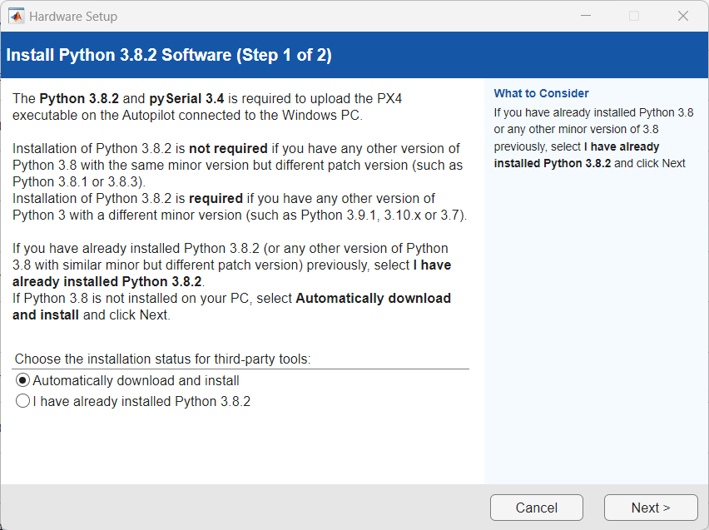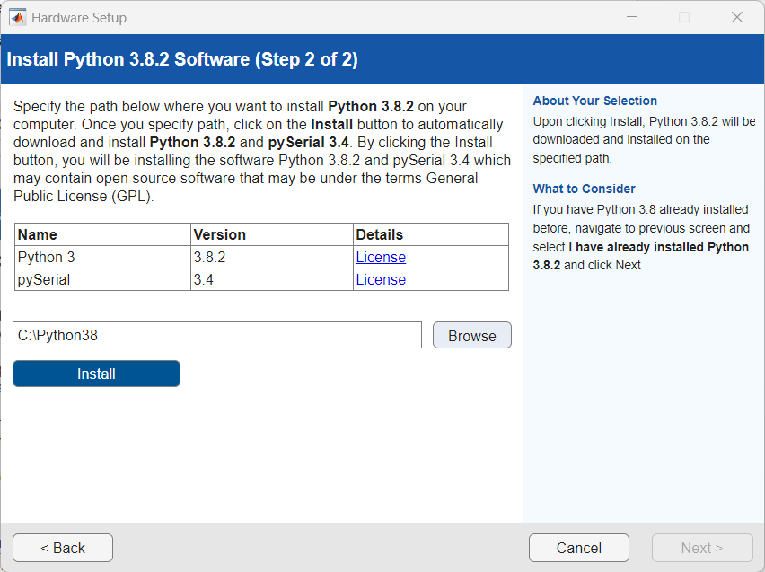

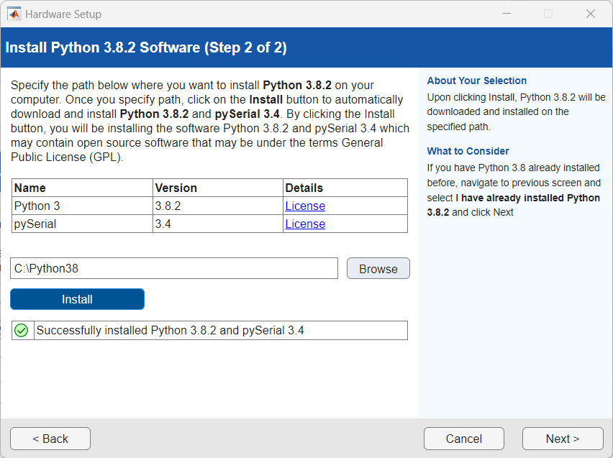
Resolve the ‘empy’ python package
The steps below prevent the following error when building PX4:
AttributeError: module 'em' has no attribute 'RAW_OPT',
The python package ‘empy’ used by WSL must be downgraded to version 3.3.4. To do so, run the following commands in the outer-most level in WSL (run ‘cd’ once to ensure you are at the outer-most level)
Run the commands in WSL
pip uninstall em
pip uninstall empy
pip install empy==3.3.4
After running these lines of code, the error will no longer occur when building PX4 through the Hardware Setup screens.
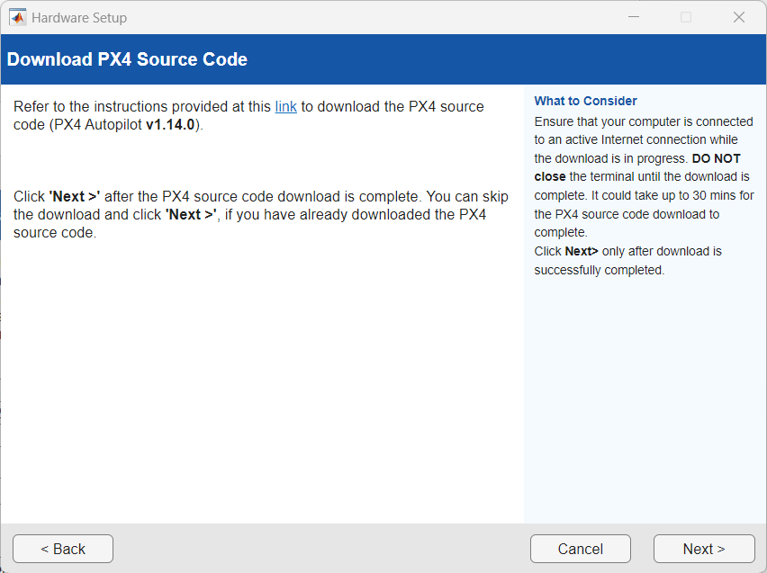
Point MATLAB toward the path of the installed PX4 repository under
Linux \Ubuntu\home\<WSL_username>\<px4_repo_name> through the File Explorer, paste the file path in the Hardware Setup window, and click validate
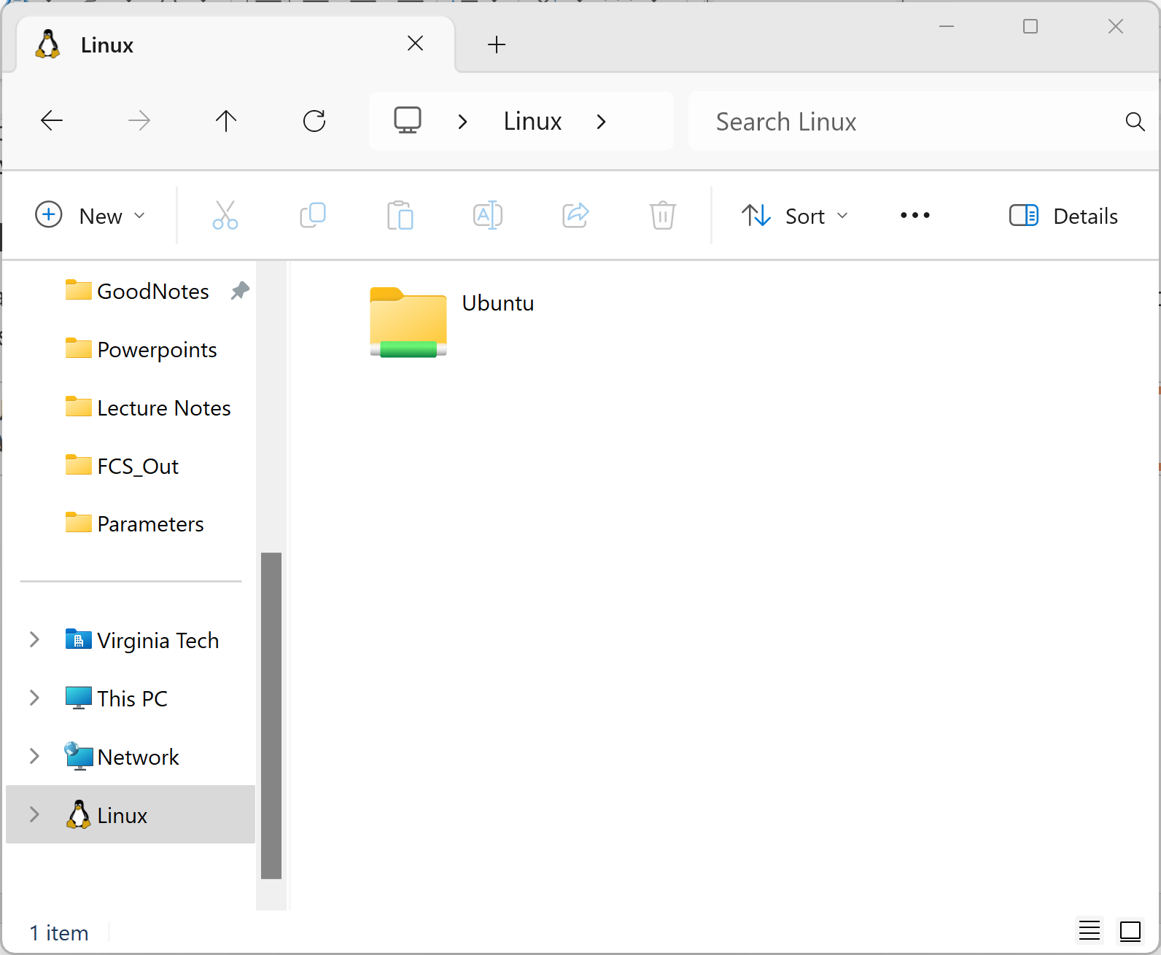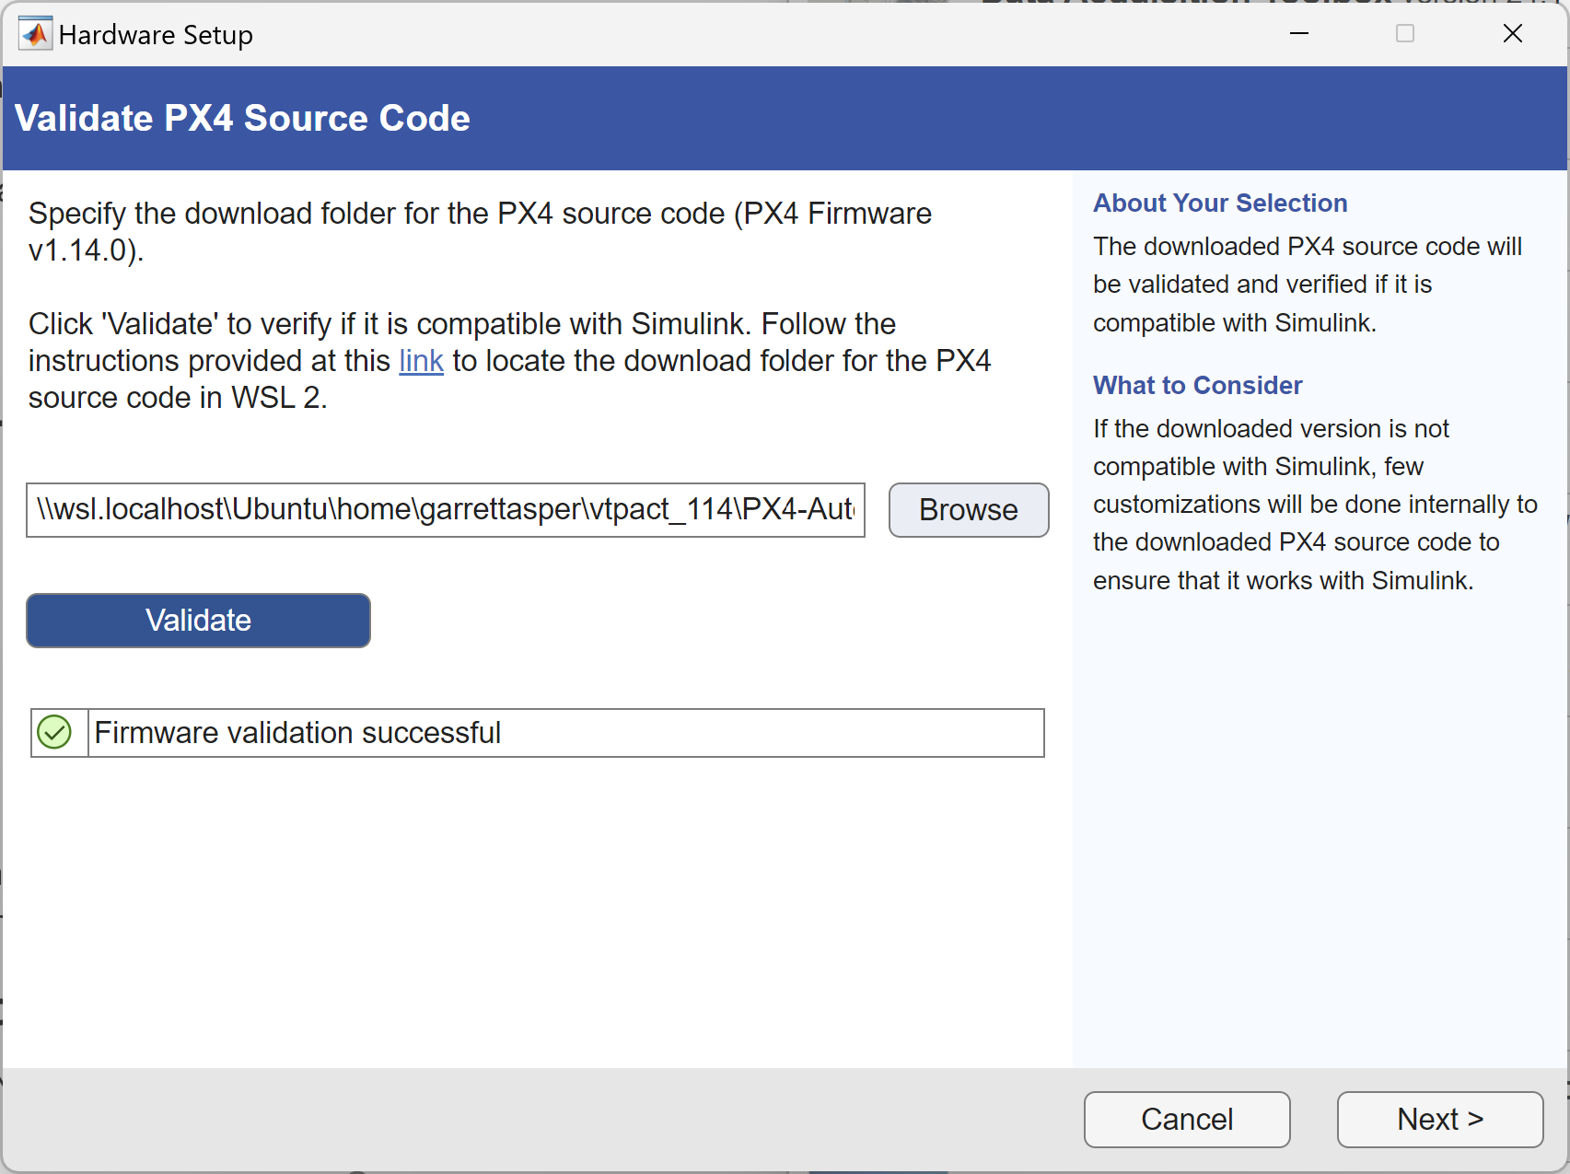
Click the next button, and uncheck the box where the PX4 controller modules. We leave this enabled for our reversionary control fallback scheme. The PX4 autopilot board is the Cube Orange+ and the build target used is the cubepilot_cubeorangeplus_default
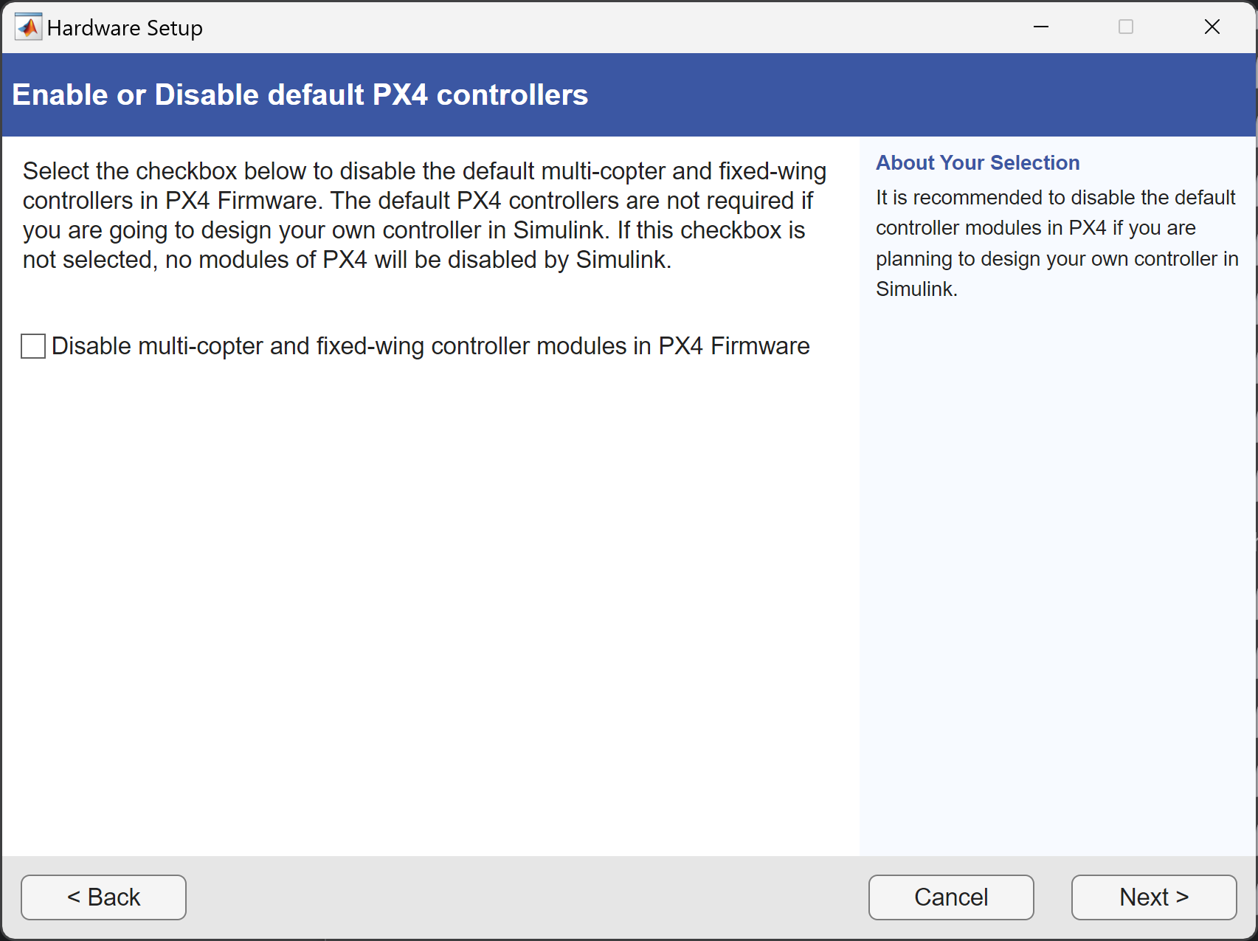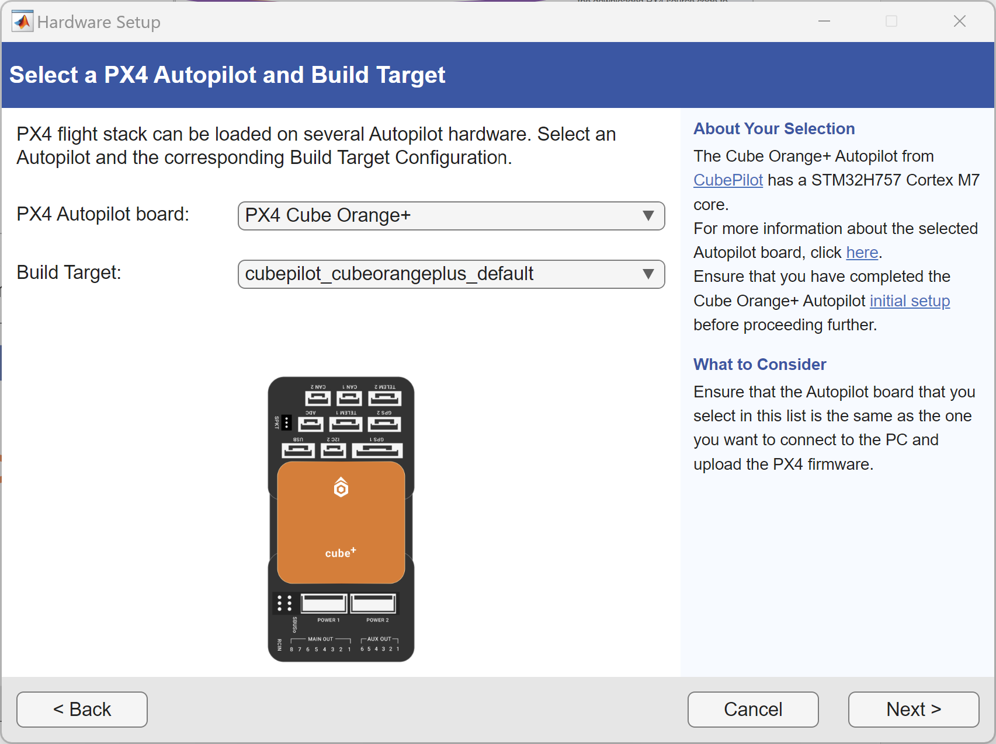
Select the default startup script and verify that QGroundControl is installed
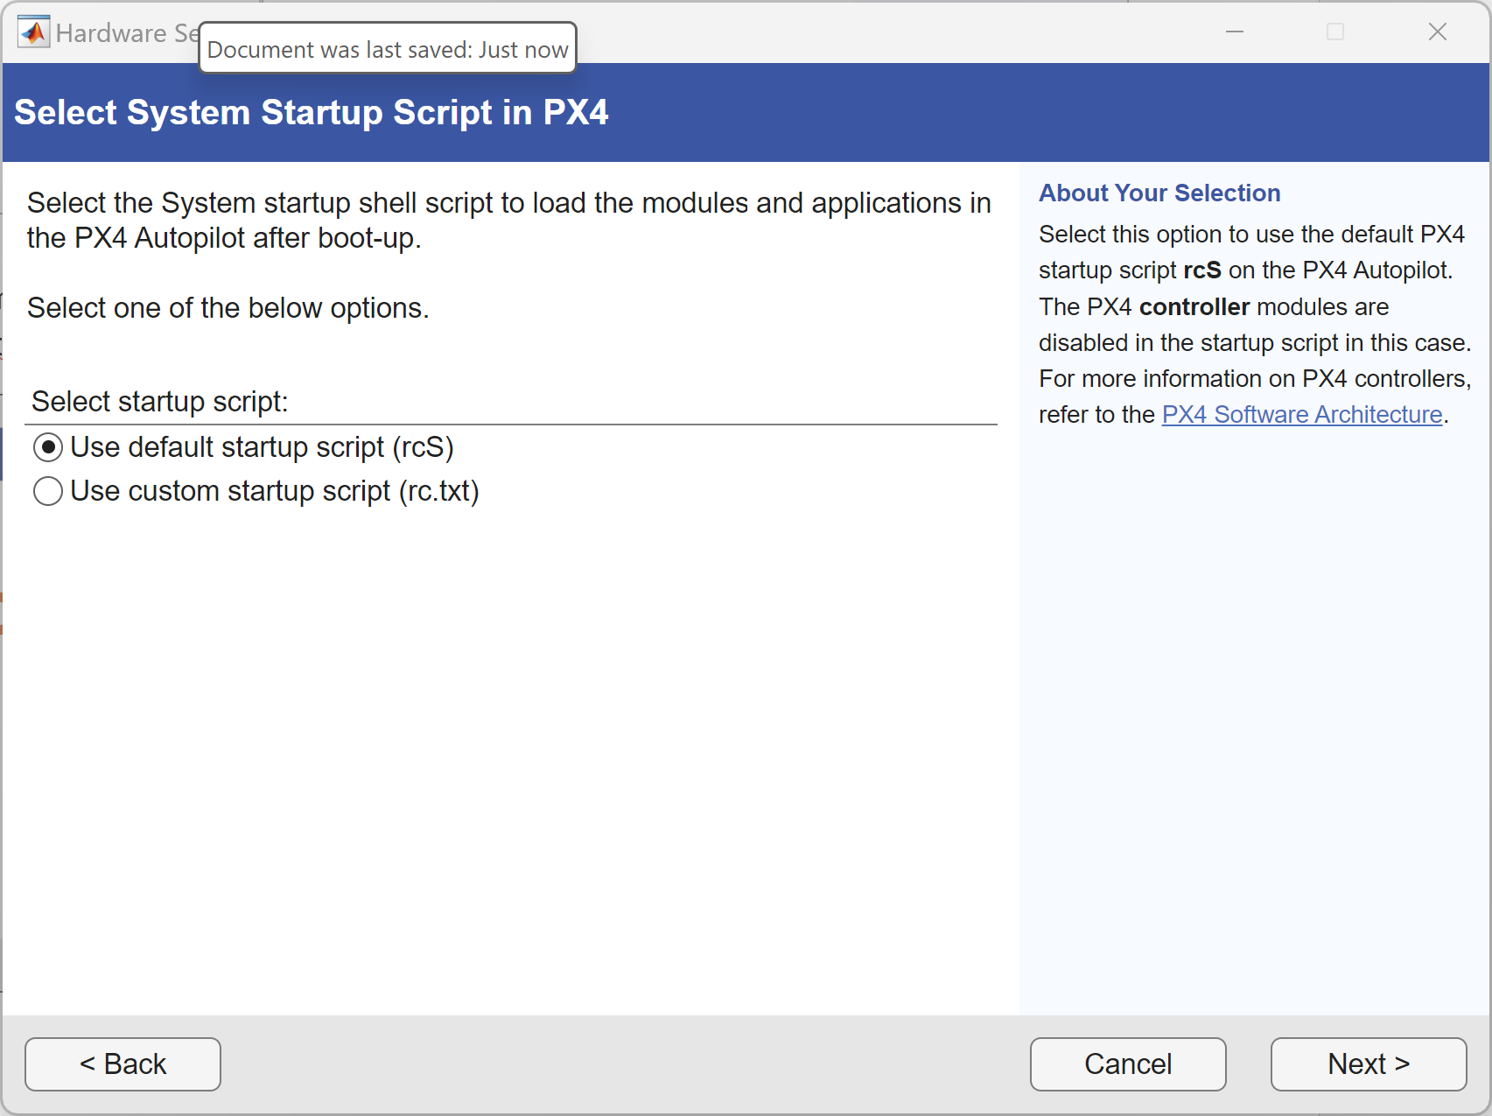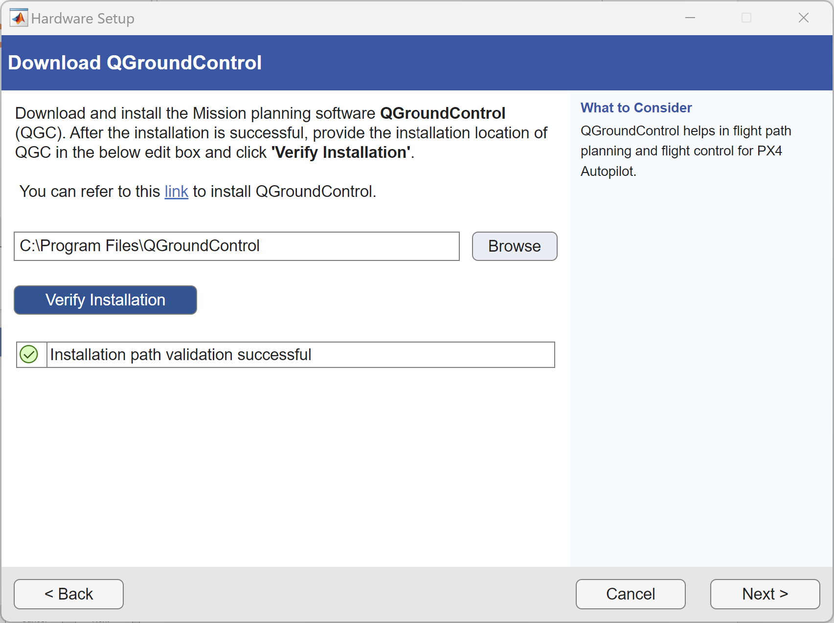
Click next on the airframe selection window as this step can be done anytime, and build the firmware. After the firmware is built, flash the firmware to the board by clicking the button to deploy it, and then rebooting the board as prompted by the pop up window.
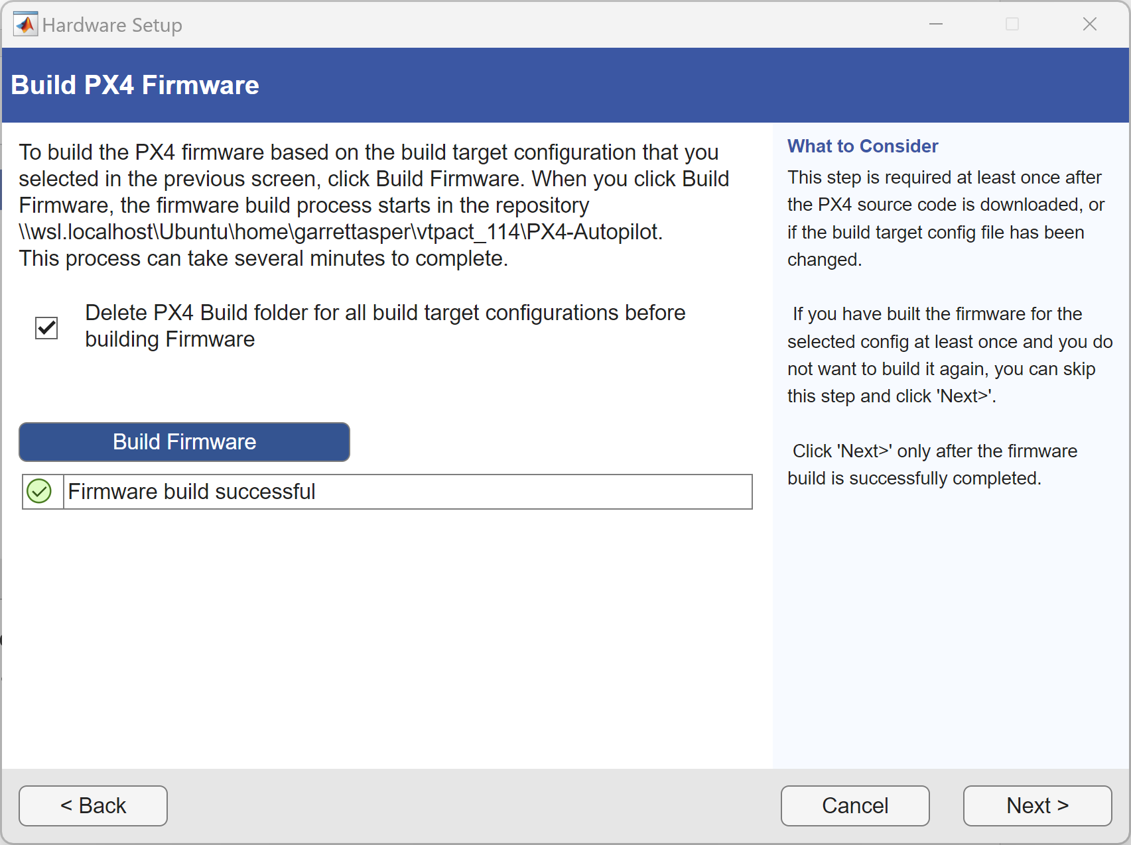
Once these steps are complete, click finish, and proceed into the Simulink model to either run a Connected IO simulation, or deploy the control diagram to the board as custom firmware.

[Recurring] Building the PX4 Base Code with the Hardware Setup Screens
The following instructions serve as steps to walk through the Hardware Setup screens. These steps must be completed before making any custom modifications to the source code (as described in section BLANK) and again after the modifications are complete.
In MATLAB, navigate to Add-Ons > Manage Add-Ons and click the gear next to the UAV Toolbox Support Package for PX4 Autopilots
Point MATLAB toward the path of the installed PX4 repository under
Linux \Ubuntu\home\<WSL_username>\<px4_repo_name> through the File Explorer, paste the file path in the Hardware Setup window, and click validate
Click the next button, and uncheck the box where the PX4 controller modules. We leave this enabled for our reversionary control fallback scheme. The PX4 autopilot board is the Cube Orange+ and the build target used is the cubepilot_cubeorangeplus_default
Select the default startup script and verify that QGroundControl is installed
Click next on the airframe selection window as this step can be done anytime, and build the firmware. After the firmware is built, flash the firmware to the board by clicking the button to deploy it, and then rebooting the board as prompted by the pop up window.
Once these steps are complete, click finish, and proceed into the Simulink model to either run a Connected IO simulation, or deploy the control diagram to the board as custom firmware.

PX4 Firmware Modifications
All modifications described in this section must be made in the PX4 base-code repository created. The general path is \Linux \Ubuntu\home\<wsl_username>\<px4_repo_name>
These modifications must be made to enable the full functionality of VTPACT.
Note: Any modification to the base-code of PX4 requires that the user goes through the Hardware Setup screens again to rebuild the repository.
Quick Start
All files necessary to modify PX4 for the VTPACT are available in folders corresponding to their subsection titles. Look for the Quick Start textbox in each section to see what files to place in the PX4 repository and where they should go.

Logging
Quick Start
Place the FcsSignals.msg in the following path
<px4_repo_name>\msg
Replace the current version of the CMakeLists.txt file on the following path with the version under version control
<px4_repo_name>\msg
Detailed Setup
To log signals internal to the Simulink diagram to a ULog topic in PX4, some modifications need to be made to the PX4 base code.
First, a new file called FcsSignals.msg must be placed in the following path:
<px4_repo_name>\msg
This file contains vectors corresponding to data topics within the FcsSignals message.
For example:
float32[3] attitude
Allocates a 3x1 vector named ‘attitude’ within the FcsSignals message.
Finally, the name of the custom message, in this case FcsSignals.msg, must be added to the CMakeLists.txt file under the following path:
<px4_repo_name>\msg\CMakeLists.txt

Telemetry
Quick Start
Place the mavlink_main.cpp file on the following path
<px4_repo_name>\src\modules\mavlink
More Details
A custom telemetry stream can be enabled through the existing DEBUG_FLOAT_ARRAY MAVLink message.
To enable the DEBUG_FLOAT_ARRAY, navigate to the mavlink_main.cpp file under the following path
<px4_repo_name>\src\modules\mavlink\mavlink_main.cpp
In the code, under the case MAVLINK_MODE_NORMAL , make the following changes
configure_stream_local("ATTITUDE", 12.0f);
configure_stream_local("ATTITUDE_QUATERNION", 5.0f);
Add the following line between configure_stream_local("COLLISION", unlimited_rate); and configure_stream_local("DISTANCE_SENSOR", 0.5f);
configure_stream_local("DEBUG_FLOAT_ARRAY", 10.0f);
Under the cases MAVLINK_MODE_NORMAL, MAVLINK_MODE_ONBOARD, MAVLINK_MODE_ONBOARD_LOW_BANDWIDTH, and MAVLINK_MODE_EXTVISIONMIN for the section with the if statement that checks for CONSTRAINED_FLASH condition, delete the following line:
configure_stream_local("DEBUG_FLOAT_ARRAY", 1.0f);
Add the following line under the case MAVLINK_MODE_CONFIG to enable the DEBUG_FLOAT_ARRAY while connected to the autopilot over USB
configure_stream_local("DEBUG_FLOAT_ARRAY", 50.0f);
Under the if statement that checks for the CONSTRAINED_FLASH condition for the case MAVLINK_MODE_CONFIG, delete the following line
configure_stream_local("DEBUG_FLOAT_ARRAY", 50.0f);

Flash Memory
Quick Start
Place the default.px4board.original file on the following path
<px4_repo_name>\boards\cubepilot\<pixhawk_board_name>
Note: This file is only valid for the default build target for the Cube Orange or Cube Orange+
More Details
The following modifications were made to free up flash memory on all three of the build targets in the repository (the three build targets being fixedwing, multicopter, and default).
Navigate to the following file path:
<px4_repo_name>\boards\cubepilot\<pixhawk_board_name>\<build_target>.px4board.original
Where <pixhawk_board_name> is either the cubeorange or cubeorangeplus and <build_target> is either default, fixedwing, or multicopter. For the case of the VTPACT, the default build target was used.
Disable the following modules by changing the ‘=y’ to ‘=n’
CONFIG_DRIVERS_CAMERA_CAPTURE=n
CONFIG_DRIVERS_CAMERA_TRIGGER=n
CONFIG_COMMON_DISTANCE_SENSOR=n
CONFIG_DRIVERS_DSHOT=n
CONFIG_COMMON_OPTICAL_FLOW=n
CONFIG_MODULES_CAMERA_FEEDBACK=n

Parameters

Custom
Quick Start
Place the module.yaml file on the following path
<px4_repo_name>\src\modules\battery_status
Repository path:
<px4_repo_name>\hardware_setup\Parameters
The Custom_PX4_Parameters.xslx is an excel sheet that contains information about the custom parameters used by the VTPACT FCS. The columns include information including the parameter name, default value, description, data type, parameter group, min, max, decimal places, and a column to check if the value currently on the vehicle differs from the default.
Once the parameters are programmed in the excel sheet as desired, use the generate_yaml.m script to generate a module.yaml file for the PX4 repository.
The current version of the module.yaml file is kept under version control.
This file must be placed in the following path:
<px4_repo_name>\src\modules\battery_status\module.yaml
After placing the yaml file in the file path above, go through the Hardware Setup Screens to build the custom parameters into PX4.
Note: Only custom parameters built as described into the module.yaml file and read in the Simulink diagram through the PX4 Read Parameter blocks will build when the custom firmware is deployed to the flight computer.
Optional: The user has the option to save a .params file to their computer through QGroundControl’s Parameters tab. Then, using the read_params_to_excel.m script, the user can generate a column of the current values of each parameter. By pasting this column into the Custom_PX4_Parameters.xslx, the user can check if the value of the parameter differs from the default setting on the vehicle.
It is recommended that the user sets any parameter values they are satisfied with as the new parameter defaults. This will prevent loss of progress in tasks including tuning, safety setting defaults, etc.
Finally, the module_original.yaml file should remain unmodified as the generate_yaml.m script relies on it.

Stock
The values set for the stock PX4 parameters are tracked in the Stock_PX4_Parameters.xlsx excel sheet. Ensure these parameters are set as described in the sheet before flight.

QGroundControl Application Settings
All configuration settings described can be completed over a wireless telemetry connection or through a hard-wired USB connection. QGroundControl typically connects to the vehicle through USB automatically, but a wireless, telemetry connection requires configuration described in the next section.

Telemetry Ports
Quick Start
If the telemetry radios on the vehicle have been configured, skip to the ‘Connecting through QGroundControl’ subsection

Initial Radio Setup
All VTPACT vehicles use the RFD 900x telemetry radios. Both the radio used by the ground station and the vehicle used must be configured through the RFDTools program.
Launch the RFD900 Tools program, and locate the COM port of the radio that is plugged in via USB. The Baud should be set to 57600 as this is the default rate used. Then, click Connect, followed by Load Settings.
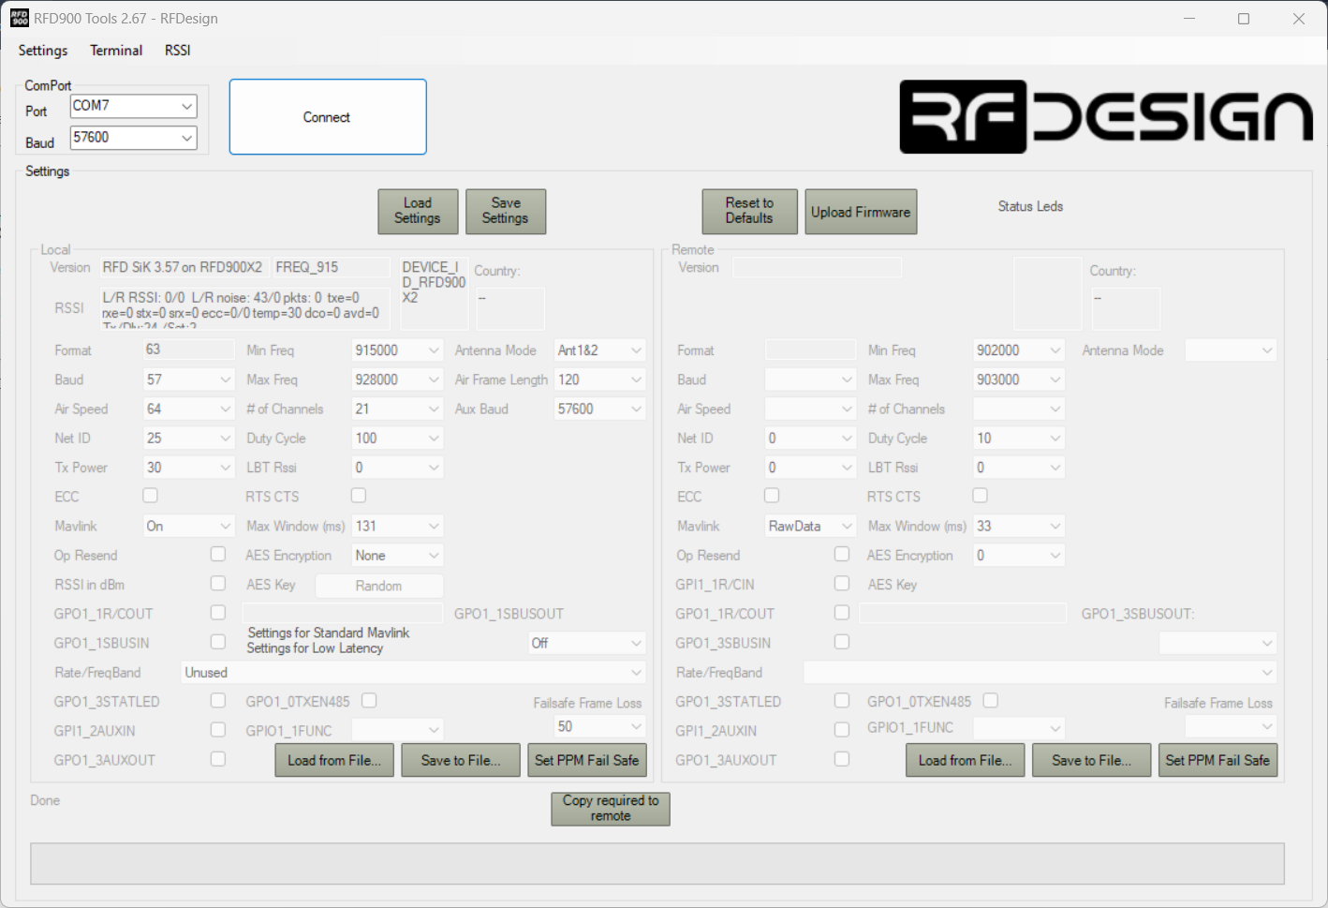
The following parameters need changed

Baud | 230
Net ID | 5n (Where n is the VTPACT number)
Tx Power | 30
Aux Baud | 230400
After these changes have been made, click Save Settings. After about 20 seconds, close the RFDTools program, and relaunch it.
Now, use the same COM port as before, but set the Baud rate to 230400, and click Connect. Click Load Settings, and verify that the changes have taken effect.
Repeat these steps for the matching radio used on the vehicle. Each parameter change will be the same across all radios in the VTPACT fleet, excluding the Net ID, which depends on the vehicle number.

Connecting through QGroundControl
To be written (describe all the way through getting it working in QGroundControl
Install the FTDI drivers for Windows through the following website:
https://ftdichip.com/drivers/
In QGC, navigate to Application Settings
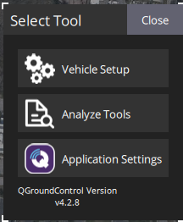
From the tabs in the left, select Comm links, then select Add
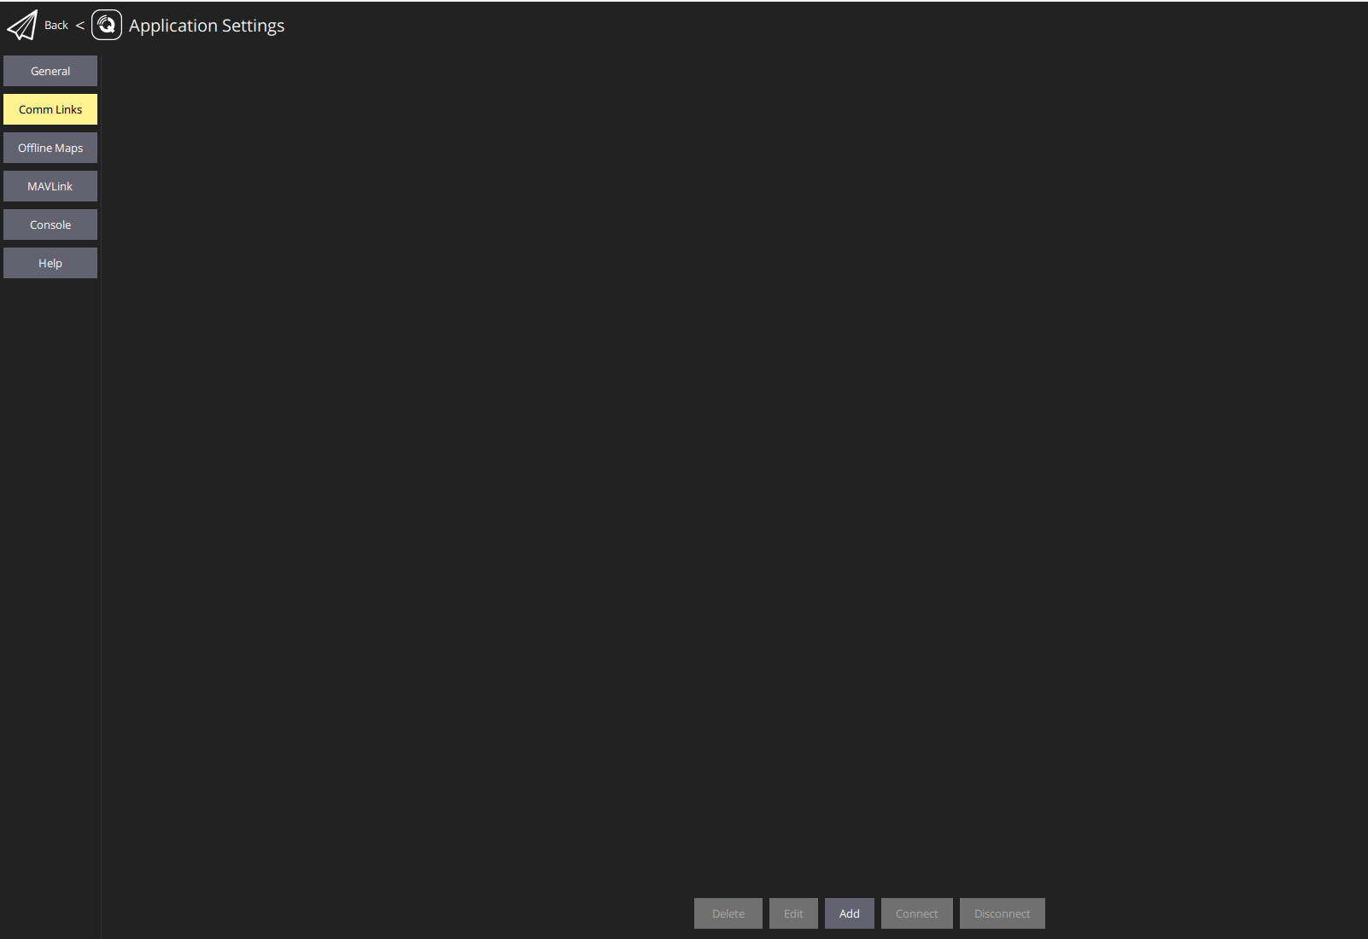
Set up the vehicle Name, select ‘Automatically Connect on Start’, change the COM port to the COM port used by the telemetry radio specific to your computer, and finally set the Baud Rate to 230400.
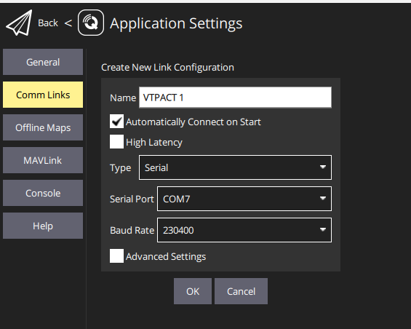
Note: Plug in the radio before launching QGroundControl since the auto-connect feature only checks for the connection when QGroundControl is started.

Custom Ground Control Station
Port forwarding must be enabled in QGroundControl to allow the custom Ground Control Station in Simulink to access the MAVLink signals received from the vehicle. To enable port forwarding, follow these steps.
In QGC, navigate to Application Settings
From the tabs on the left, select MAVLink and check the box next to Enable MAVLink forwarding
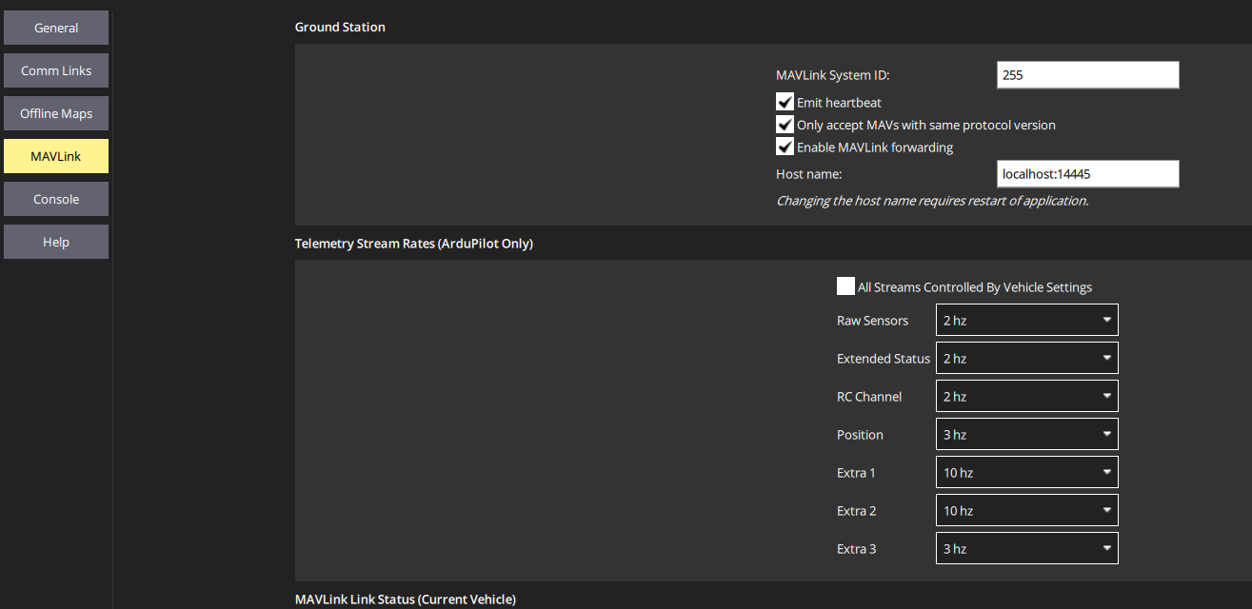

QGroundControl Vehicle Setup
These setup instructions outline the settings necessary for the VTPACT.
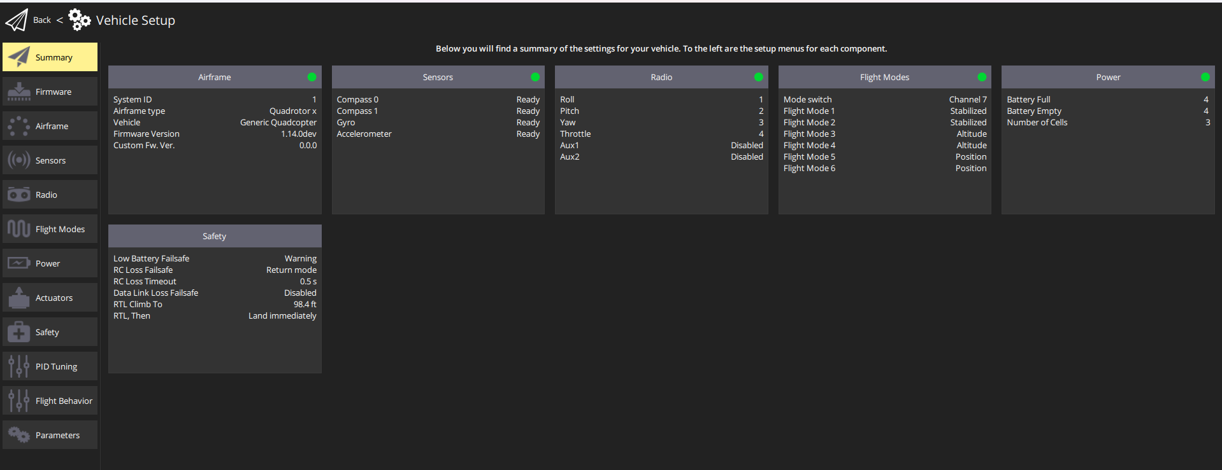

Airframe
The VTPACT uses the Generic Quadcopter airframe. Once this airframe is set, click the apply and restart button for the change to take effect.
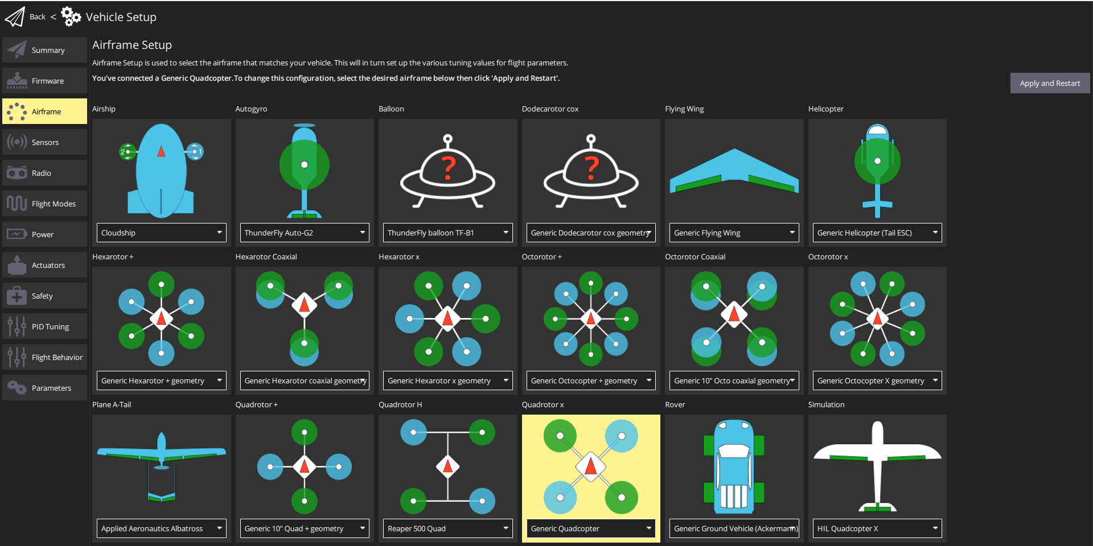

Sensors
The Accelerometer, Gyroscope, and Compass should be calibrated before initial bench testing. Recalibration may be required outside.
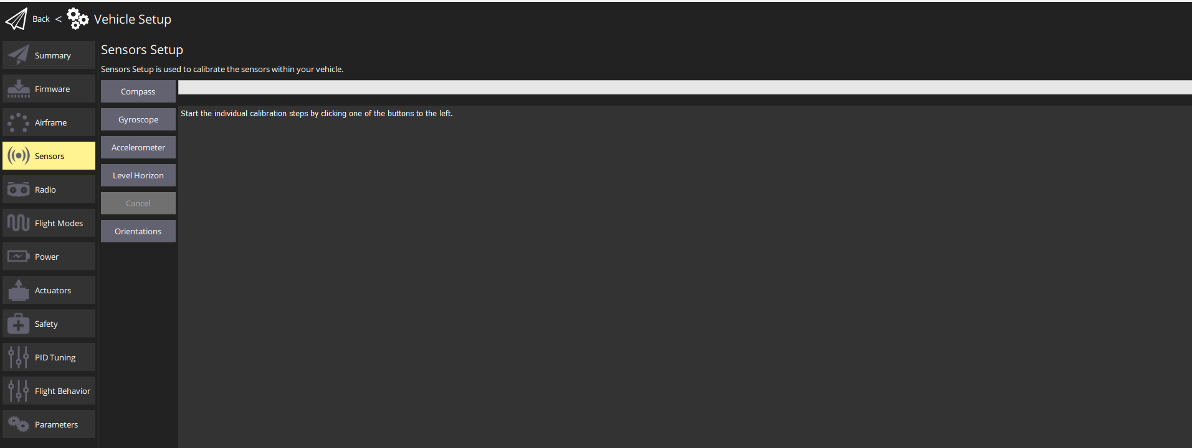

Radio
The radio used for the VTPACT Setup is the Spektrum ix20 with a DSMX protocol receiver. The pair can be bound using the spektrum bind button under the Radio tab. Additional details for the binding process can be found online. When a radio is first set up with a VTPACT, a calibration is required to map the extremes of each stick and switch. QGroundControl walks the user through the orientations to move the transmitter inputs through.
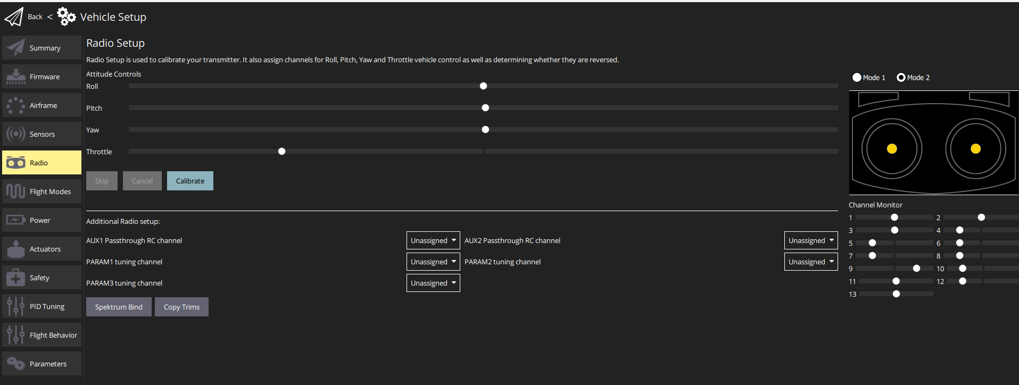

Flight Modes
The flight modes tab allows the user to set switch functions on the transmitter. In the case of the VTPACT, the switches that need set in this menu are as follows
Channel 5 | Arm switch channel
Channel 12 | Emergency Kill switch channel
Channel 7 | Mode Channel

The flight modes should be configured as follows
Flight Mode 1 & 2 | Stabilized
Flight Mode 3 & 4 | Altitude
Flight Mode 5 & 6 | Position
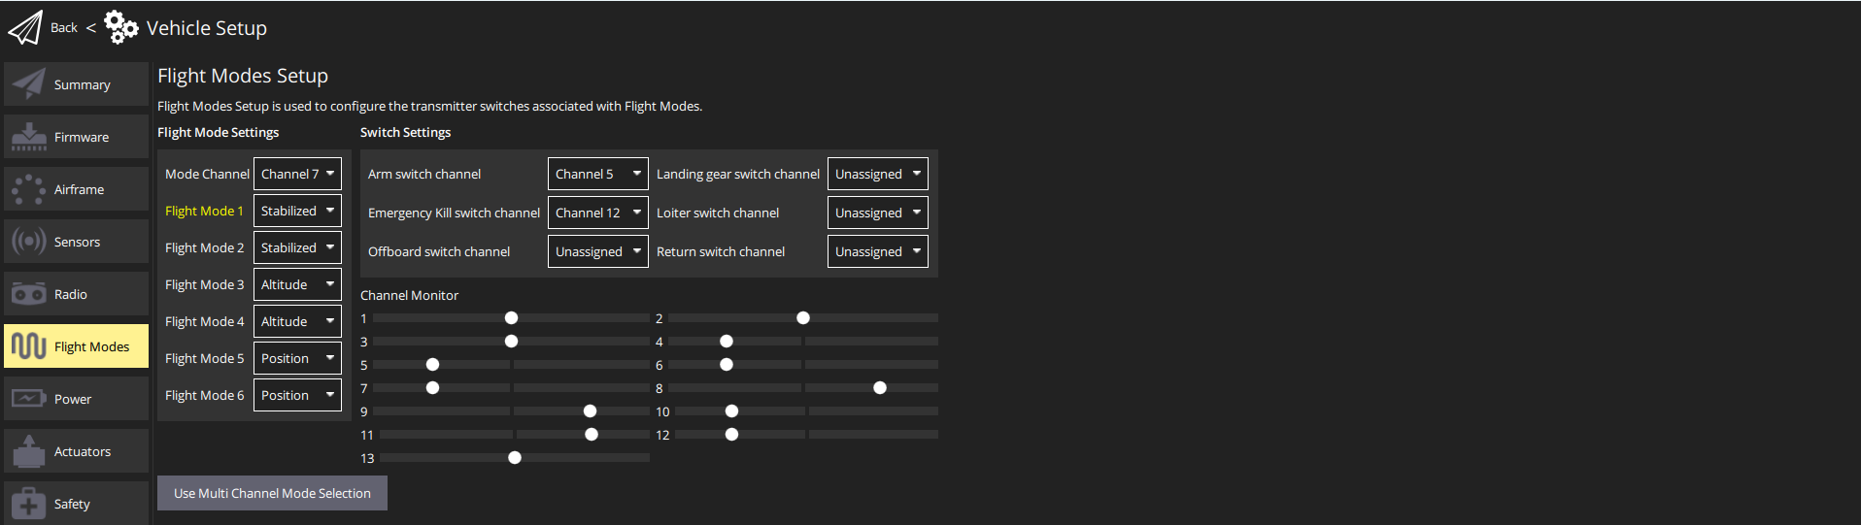

Power
The following parameters must be set for the Power tab
- Source: Power Module
- Number of Cells (In Series): 4
- Empty Voltage (per cell): 3.6
- Full Voltage (per cell): 4.2
- Voltage divider: *Set according to the power module specifications specific to each VTPACT*

Actuators
Under the actuator tab, navigate the UAVCAN panel, and assign the function of ESC 1 – 4 to Motor 1 – 4, respectively. The minimum and maximum values should be set to
Minimum: 376 & Maximum: 8191
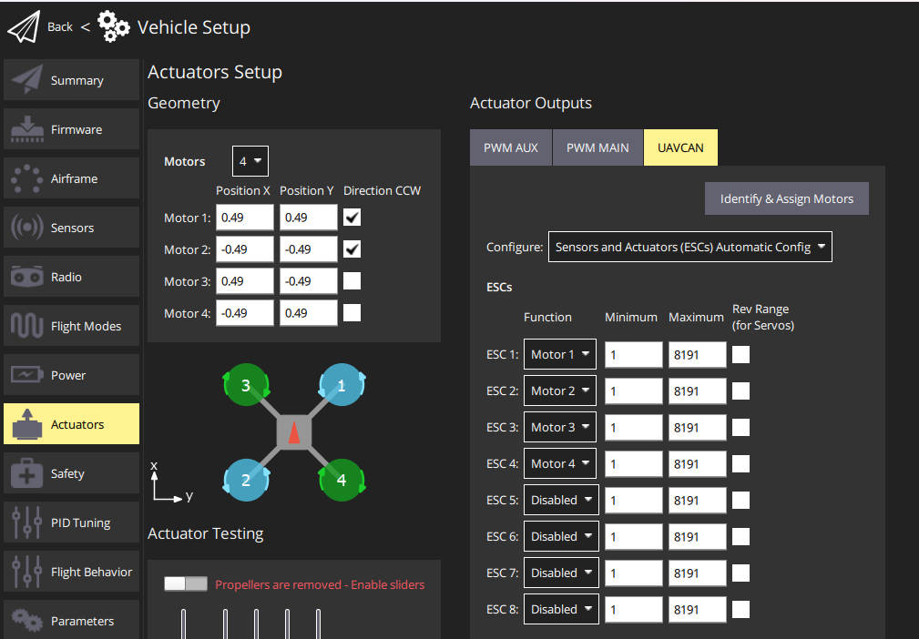

Safety
The safety settings were configured according to the screenshots below
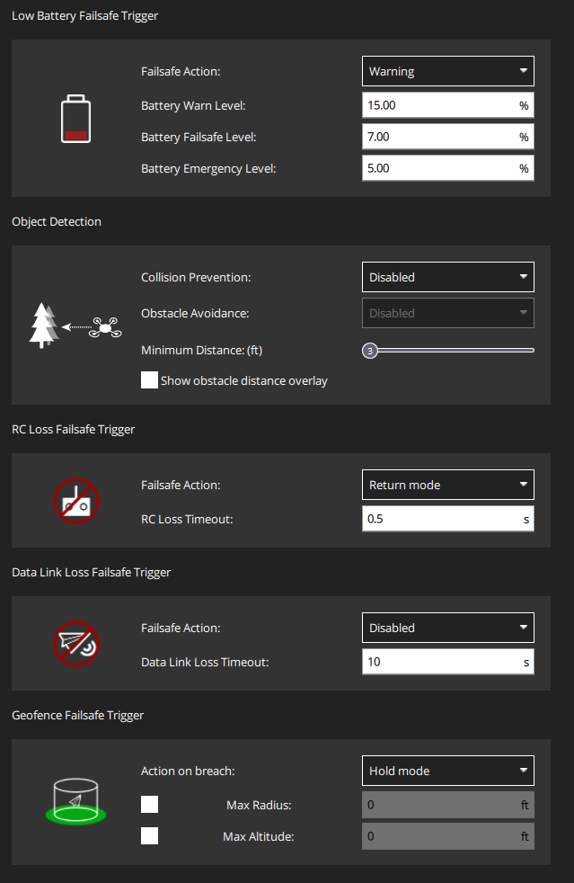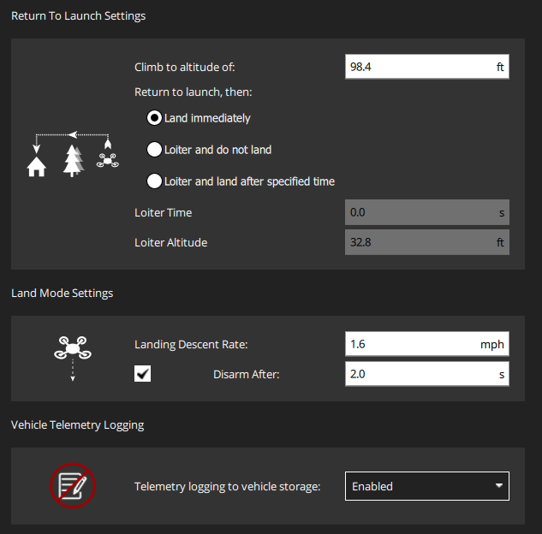

Parameters
The file path below contains two excel sheets used to track the current and most up-to-date parameters used on the VTPACT
<px4_repo_name>\hardware_setup\Parameters
The values set for the stock PX4 parameters are tracked in the Stock_PX4_Parameters.xlsx excel sheet.
The Custom_PX4_Parameters.xslx contains all parameters built for the VTPACT FCS.
Ensure the parameters from both excel sheets are set as described before flight.

